USECASE DAIGRAM:



ACTIVITY DAIGRAM:



Component diagram



Deployement diagram:



Class diagram

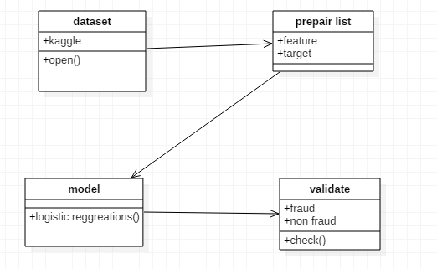

Sequence diagram

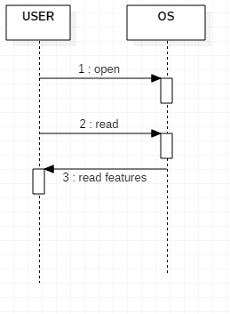

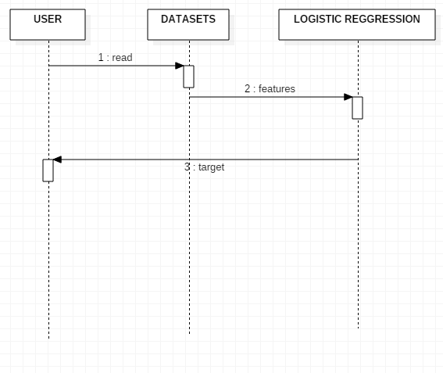

Data flow diagram

